

Decentralized Control Information Structures Preserved
Under Feedback

Michael Rotkowitz^{1,3} Sanjay LallIEEE Conference on Decision and Control, 2002

Abstract
We consider the problem of constructing decentralized
control systems. We formulate this problem as one of
minimizing the closed-loop norm of a feedback system
subject to constraints on the controller structure. We
define the notion of quadratic invariance of a constraint
set with respect to a system, and show that if the con-
straint set has this property, then the constrained mini-
mum norm problem may be solved via convex program-
ming. We also show that quadratic invariance is neces-
sary and sufficient for the constraint set to be preserved
under feedback.
We develop necessary and sufficient conditions un-
der which the constraint set is quadratically invariant,
and show that many examples of decentralized synthe-
sis which have been proven to be solvable in the liter-
ature are quadratically invariant. As an example, we
show that a controller which minimizes the norm of the
closed-loop map may be efficiently computed in the case
where distributed controllers can communicate faster
than the propagation delay of the plant dynamics.

Keywords: Decentralized control, convex optimization

1 Introduction
An important problem in control is that of constructing
decentralized control systems, where instead of a single
controller connected to a physical system, one has mul-
tiple separate controllers, each with access to different
measured information and with authority over differ-
ent decision or actuation variables. Examples of such
systems include automobiles on the freeway, the elec-

variations correspond to structural features of the sys-
tem and structural constraints on the allowable con-
trollers, such as sparsity constraints. In general, find-
ing a norm-minimizing controller subject to such con-
straints is not a convex optimization problem, and in many cases it is intractable. In this paper we show that if the constraints on the controller satisfy a partic-
ular property, called quadratic invariance, with respect to the system being controlled, then the constrained minimum-norm control problem may be reduced to a convex optimization problem.
1.1 Notation
We make use of the following notation. If X and Y
are Banach spaces, we denote by L(X , Y ) the set of
all bounded linear maps A : X → Y . We abbreviate
L(X , X ) to L(X ). A map A ∈ L(X ) is called invertible
if there exists B ∈ L(X ) such that AB = BA = I . For
S ⊂ X and T ⊂ X^{2,3}
∗ define
{ }
S ⊥ = x∗ ∈ X ∗ ; 〈x, x∗ 〉 = 0 for all x ∈ S
{ }
⊥T = x ∈ X ; 〈x, x∗ 〉 = 0 for all x∗ ∈ T
where X ∗ is the dual-space to X . For any map A ∈ L(X ) define the resolvent set ρ(A) by ρ(A) = {λ ∈ C; (λI − A) is invertible} and the resolvent R_{A} : ρ(A) → L(X ) by R_{A} (λ) = (λI − A)⁻¹ for all λ ∈ ρ(A). We also define ρ_{uc} (A) to be the unbounded connected component of ρ(A).
As is standard, L₂ is the Hilbert space of square in-
tegrable functions f : R₊ → X . For c ≥ 0 define the delay map D_{c} : L₂ → L₂ by
{
u(t − c) if t ≥ c

tricity distribution grid, flocks of aerial vehicles, and
spacecraft moving in formation.
There are many variations of this problem, depending
on how the limited availability of information is speci-
fied, the structure of the physical systems, and whether
and how separate controllers can communicate. These
¹ Email: rotkowitz@stanford.edu
y = D_{c}u if y(t) =
0 otherwise
1.2 Preliminaries
Suppose U , W , Y , Z are Banach spaces, and P is a con-
tinuous linear map P : W × U → Z × Y . Partition P
as [ ]
P₁₁ P₁₂

² Email: lall@stanford.edu P =
³ Department of Aeronautics and Astronautics 4035, Stanford
P₂₁ P₂₂

University, Stanford CA 94305-4035, U.S.A.
The first author was partially supported by a Stanford Gradu-
ate Fellowship. Both authors were partially supported by the
Stanford URI Architectures for Secure and Robust Distributed
Infrastructures, AFOSR DoD award number 49620-01-1-0365.

1
so that P₁₁ : W → Z , P₁₂ : U → Z , P₂₁ : W → Y and
P₂₂ : U → Y . Suppose K ∈ L(Y , U ). If I − P₂₂ K is invertible, define f (P, K ) ∈ L(W , Z ) by
f (P, K ) = P₁₁ + P₁₂ K (I − P₂₂ K )⁻¹ P₂₁

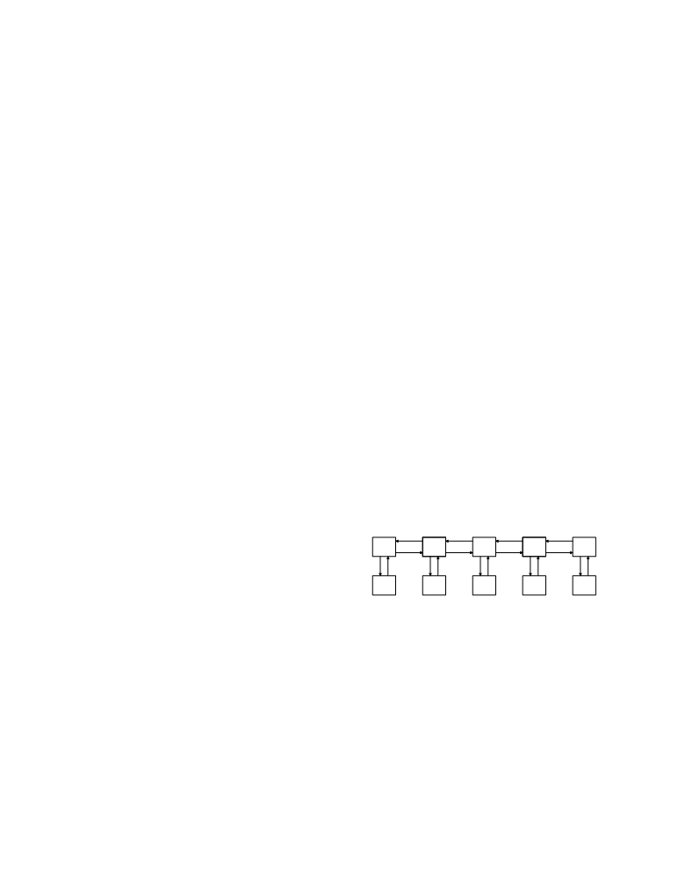

The map f (P, K ) is called the (lower) linear frac-
tional transformation (LFT) of P and K ; we will
also refer to this as the closed-loop map . Given
P₂₂ ∈ L(U , Y ), we define the set M ⊂ L(Y , U ) of con-
trollers K such that f (P, K ) is well-defined by
{ }
M = K ∈ L(Y , U ) ; (I − P₂₂ K ) is invertible
and define the subset N ⊂ M by
{ }
N = K ∈ L(Y , U ) ; 1 ∈ ρ_{uc} (P₂₂ K )
In the remainder of the paper, we abbreviate our nota-
tion and define G = P₂₂ .
1.3 Problem formulation
Suppose S ⊂ L(Y , U ) is a closed subspace. Given P ∈ L(W × U , Z × Y ), we would like to solve the following problem.
minimize ∥f (P, K )∥
subject to K ∈ S (1)
K ∈ M
Here ∥·∥ is any norm on L(W , Z ), chosen to encapsulate
the control performance objectives, and the constraint
that K ∈ S may represent sparsity or delay constraints
on K . We call the subspace S the information con-
straint .
This problem is very general, in the sense that the
signal spaces U , W , Y , Z may be continuous-time, such
as L₂ , or discrete-time, such as ℓ₂ , and the signals and
systems may evolve over infinite time, with U , W , Y , Z
function spaces over [0, ∞) or Z₊ , or over finite time
intervals. Also the norm on L(W , Z ) may represent ei-
ther a deterministic measure of performance, such as the induced norm, or a stochastic measure of perfor-
mance, such as the H₂ norm.
It is also important to notice that the controller K
is required to be linear. While this is a serious and
non-trivial limitation, it allows us to state very sharp
conditions under which the problem may be solved. Im-
portant work has also considered related problems for
nonlinear control with a stochastic performance index;
see Section 2.
Both P and K are required to be bounded maps.
In particular, if P and K are represented by rational
transfer functions, this requirement is tantamount to
the constraint that P and K be stable. We relax this constraint in Section 4.1 below.
This problem is made substantially more difficult in
general by the constraint that K lie in the subspace
S . Without this constraint, the problem may be solved
by a simple change of variables, as discussed below.
Note that the cost function ∥f (P, K )∥ is in general a
non-convex function of K . Even for finite-dimensional
spaces U , W , Y , Z , no computationally tractable ap-
proach is known for solving this problem for arbitrary P
and S .

2

1.4 Quadratic invariance
The following is the major property that we will use in this paper.
Definition 1. Suppose G ∈ L(U , Y ), and S ⊂ L(Y , U ).
The set S is called quadratically invariant under G
if
KGK ∈ S for all K ∈ S
Note that, given G, we can define a quadratic map Ψ : L(Y , U ) → L(Y , U ) by Ψ(K ) = KGK . Then a set S is quadratically invariant if and only if S is an invariant set of Ψ; that is Ψ(S ) ⊂ S .
In the following, we will show that, subject to appro-
priate technical assumptions on S and G, a subspace S is quadratically invariant if and only if
K (I − GK )⁻¹ ∈ S ⇐⇒ K ∈ S
It is a consequence of this result that, when S is quadratically invariant, the set of achievable closed-
loop maps
{ }
P₁₁ + P₁₂ K (I − GK )⁻¹ P₂₁ ; K ∈ S
is affine, and hence convex.
1.5 Some examples
Many standard centralized and decentralized control problems may be represented in the form of prob-
lem (1), for specific choices of P and S . Examples include the following.
Perfectly decentralized control. We would like to design n separate controllers {K₁ , . . . , K_{n} }, with con-
troller K_{i} connected to subsystem G_{i} of a coupled sys-
tem, as in the diagram below.
G₁ G₂ G₃ G₄ G₅

K₁ K₂ K₃ K₄ K₅
When reformulated as a synthesis problem in the LFT framework above, the constraint set S is
{ }
S = K ∈ L(Y , U ) ; K = diag(K₁ , . . . , K_{n} )
that is, S consists of those controllers that are block-
diagonal.
Delayed measurements. In this problem, we have n linear time-invariant subsystems {G₁ , . . . , G_{n} }, each with its respective controller K_{i} , arranged so that sub-
system i receives signals from controller i after a com-
putational delay of c, and controller i receives measure-
ments from subsystem j with a transmission delay of t|i − j |. Also subsystem i receives signals from subsys-
tem i + 1 delayed by propagation delay p.

